INTRODUCTION TO WEB

- What is web?
The Web (World Wide Web) a global information system of interconnected documents, images, and resources accessible via the internet using browsers. It is a system of interlinked web pages and web applications that are accessed using the Internet. It allows users to view information, communicate, learn, and perform online activities through browsers. It consists of websites and web pages containing text, video, and audio, organized by URLs.
- WWW (World Wide Web)
The World Wide Web (WWW) is a service on the Internet that allows users to access web pages using browsers, Consists of web pages, websites, and hyperlinks
- Invented by Tim Berners-Lee in 1989.
- It operates on HTTP to link data together.

- What is Internet?
It is a worldwide network-system, Internet is a global network of computers connected to each other using standard communication protocols. Allows sharing of data, files, emails, videos, etc.
Example: Email, video calls, file transfer, online games all use the Internet.

- What are Web Terminologies?
Web terminologies are the basic terms used while working with the Internet, websites, and web development.
- Internet: It is a worldwide network system.
- Browser: It is standalone application through which you can access data with help of internet and runs the websites for output.
- Web: It is a system of interlinked web pages and web applications that are accessed using the Internet.
- Server: A web server is software that stores, processes, and delivers website content (HTML, images, CSS) as response to users request via HTTP/HTTPS over a network.
- Websites: A collection of multiple related web pages stored on a server and accessed using a single domain name.
- Webpages: A single HTML document that is part of a website accessible through browser and contains text, images, hyperlinks, maps, icons, etc. Webpages are the building blocks of a website.
- Hyperlink: A clickable link that connects one web page to another.
- URL(Uniform Resource Locator): The address of a web resource on the Internet.
- Domain Name: A human-readable name that identifies a website.

- How Websites Work
Steps involved when you open a website:
- User enters a URL in browser
- Browser sends a request to the server
- Server processes the request
- Server sends HTML/CSS/JS as response
- Browser displays the webpage

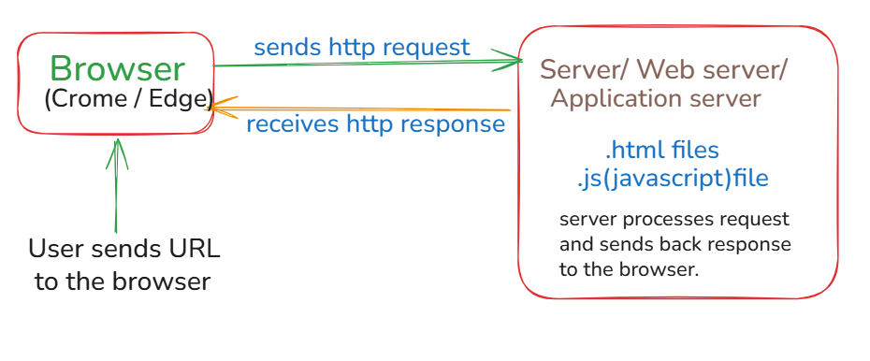

Static and Dynamic Websites
 | Static Website | Dynamic Website
1 | Users can’t modify the content. | Users can modify the content.
2 | Static websites are same for all users | Dynamic websites are different for all users.
3 | Only specific content or particular page is reloaded. | Entire website will be refreshed or reloaded.
4 | There is no database. | Database is present.
5 | Technologies used are HTML, CSS. | Backend technologies Python, JS, Java, etc.
Ex: | Geeks for Geeks, Wikipedia. | Ex: Instagram, Amazon.

5.Web applications:

Web applications are software programs accessed via a web browser over the internet, an application is a software that solves the real – world problem, it performs
a specific task and which is interactive with the user. They use web technologies (HTML, CSS, JavaScript) to provide interactive experiences, offering accessibility across devices and automatic updates. There is different type of application: -

a) Standalone Application:
- A standalone application is an application that runs independently on a single device without needing a network connection or a server.
- In standalone application, the application is locally installed inside a computer or phone and works offline without internet.
- This application doesn’t depend on other machines and browsers.
- All the data and logics are stored locally.
- Examples – Calculator, notepad, MS paint

b) Client – Server Application:
- Client – Server Model is a way for two computers to talk to get a job
done.
- In this application, we need a network connection where client requests services and server provide services.
- Here, Multiple clients can connect to one server.
- Example: Email systems, Railway reservation system

c) Web Applications:
  - Web application or web app is a program that we use through a web
browser instead of installing into a computer’s hard drive.
  - In web application, it requires internet and there is no requirement of installation.
  - Web applications are software programs that run on web servers and are accessed through browsers.
- Example: Instagram, Online shopping websites

- Architecture of applications:
For developing any application, it is required to have an architecture. So, there
are mainly three types of architecture: -

1. One – tier Architecture –
a) ONE – tier architecture is an architecture where all the component of
an application is located on a single machine such as UI, business logic, data all present in one system. ONE-tier- architecture is used to make standalone application.
- How it works –
1) User interact directly with the application.
2) Processing and data storage happens on the same device.
3) No network communication is required.
- Advantage –
- Simple to design.
- Used for small applications
- Fast in performance
- No network dependency.
- Disadvantage –
1) Data is not secure.
2) No multi – user support.
3) Hard to maintain the large system.
- Example: Calculator, Notepad

2. Two – tier Architecture –
a) Two – tier architecture divides an application into two layers: -
i. Client – Known as user interface that runs on user’s desktop to interact with system.
ii. Server – It stores, manages, runs business logic and transactions.
- Advantage –
1) It’s better than one – tier architecture.
2) It supports multi – user
3) It is Faster than three – tier architecture for small systems.
- Disadvantage –
1) Heavy load on database
2) Maintenance become difficult as user increases.
- Example: Library Management System
- How it works –
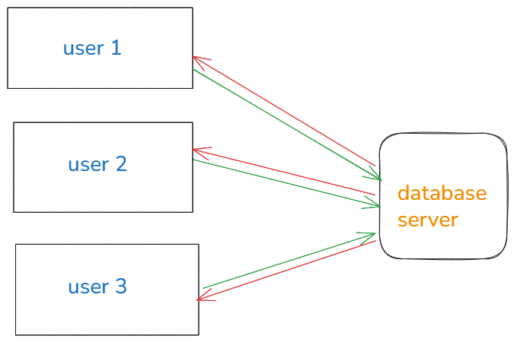
1) Multiple User interacts with the server.
2) Client(browser here acts as a client) sends request to the database
3) Database runs the data
4) Server process and display the results on client(browser).
3. Three – tier Architecture –
a) A three – tier architecture is used to create a web application.
b) It is a setup where an application is split into 3 layers:
Presentation Layer, Application Layer and Data Layer.
- How it works –
- User interacts with the client (browser).
- client sends the request to the server
- Server layer (logic layer) often written in programming languages, receives requests and sends to data layer to store and retrieve information.
- database runs the data, and returns requested data to the application layer.
- Application layer then sends the formatted result back to presentation layer.
- Client receives the response and displays the results.
- Advantage –
1) High Security
2) Better performance for larger system.
- Disadvantage –.
1) More Complex
2) Requires skilled development
- Example: E – Commerce platform, Banking System

